Assignment 6 Xiangzhu Chen

Reflection

**The challenges of coding and how I overcame them**

The first challenge I encountered was to internalize the concept of object and map out the constructor function Item() for later use. I watched YouTube videos and asked peers, then finally learned the abstract logic of the this.example = example properties inside the object.

The next challenge was to grab the value of sizes and colors from the product detail page because they were images initially, which did not have an value. For sizes, I changed them into divs, and added active status class to them, which would be called when the div is selected. Also when the div was selected, the text value inside the div would be grabbed as well. Things were a bit more difficult for colors.

After grabbing the values I needed and implemented the add to cart function which created new items and push them into the shopping cart array, I found all the objects had undefined properties, which meant that none of the values I grabbed were passed in. I solved this problem by creating a current cart array first, and store all the properties such as name, size, price, etc. to it, then

**Takeaways**

1. 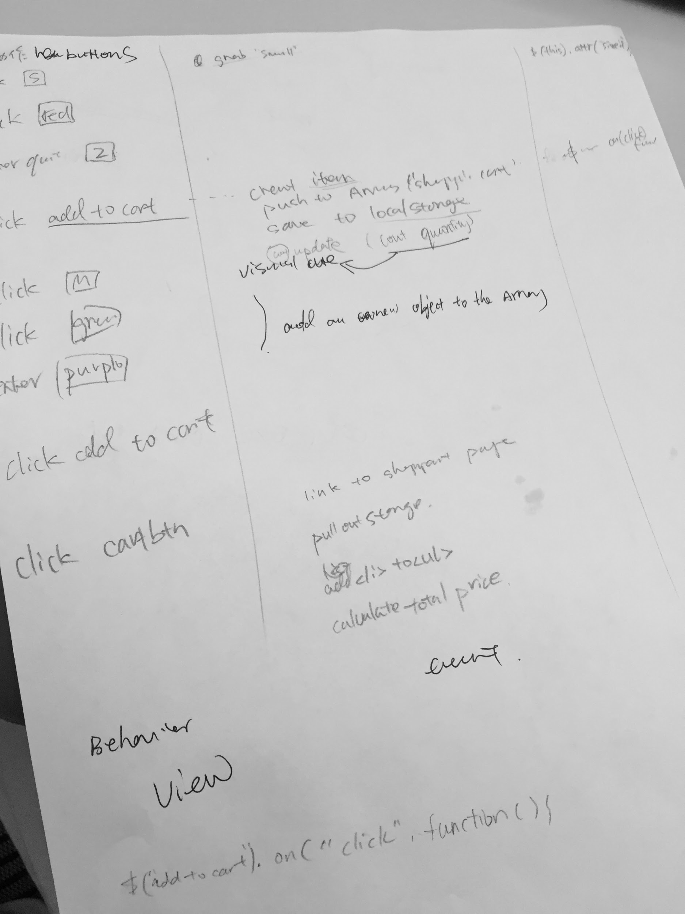Start early: I found myself spend much more time debugging than writing up the initial individual functions. The real challenges came when I tried to link these functions together and make the overall logic flow. Next time I would first draw out logic clearly on paper, then use comments to layout them in the codes, then dive into the actual coding process.
2. MVC is very helpful. I unconsciously used this framework while trying to make connections between user’s behaviors, in other words the events happen on the page, to the codes behind them. After I draw out links on the page, I got a better understanding of how event-based programming is like, and the separation of concern principles. (on the right is my sketch of relationship between behavior, events, codes)

**Things could’ve done better with more time**

The major revise I would like to make is refining the CSS so that some small visual detail could be cleaner. For example, the alignment of the price and buttons on product detail page could be aligned better at a fixed vertical line. Also, the two buttons of wish list and shopping cart could be styled to be more similar to the hi-fi prototypes.

**Citations of tutorials**

<https://www.youtube.com/watch?v=ES1jky86JLQ&list=PLoN_ejT35AEhzNoPStBzAkpqAu3YQwPj7&index=9>

This is a major tutorial of shopping cart js codes I watched. It was really helpful, and after watching this list of videos every day for one week, I successfully learned using objects, local storage, array, and major functions associated with them, such as counting the quantity and price.

<https://love2dev.com/blog/javascript-remove-from-array/>

<https://stackoverflow.com/questions/47032704/multiple-conditions-using-an-and-if-statement-javascript>

<https://www.imooc.com/learn/386> (This is a free class of how to make a carousel)

<https://stackoverflow.com/questions/1735230/can-i-add-custom-attribute-to-html-tag>

<https://stackoverflow.com/questions/554273/changing-the-image-source-using-jquery>

<https://stackoverflow.com/questions/11563638/how-do-i-get-the-value-of-text-input-field-using-javascript>

<https://www.w3schools.com/html/html_tables.asp>

<https://www.w3schools.com/jquery/sel_last.asp>

<https://www.oreilly.com/library/view/javascript-cookbook/9781449390211/ch12s13.html>

<https://www.w3schools.com/js/js_loop_for.asp>

<https://www.w3schools.com/jsref/met_storage_getitem.asp>